The Get Involved Fair, hosted by the Center for Campus Involvement, is held twice a year during the fall and spring semesters. On the first Thursday of September, students gather in the Alfond Sports Center to learn more about the different organizations and opportunities available on campus.
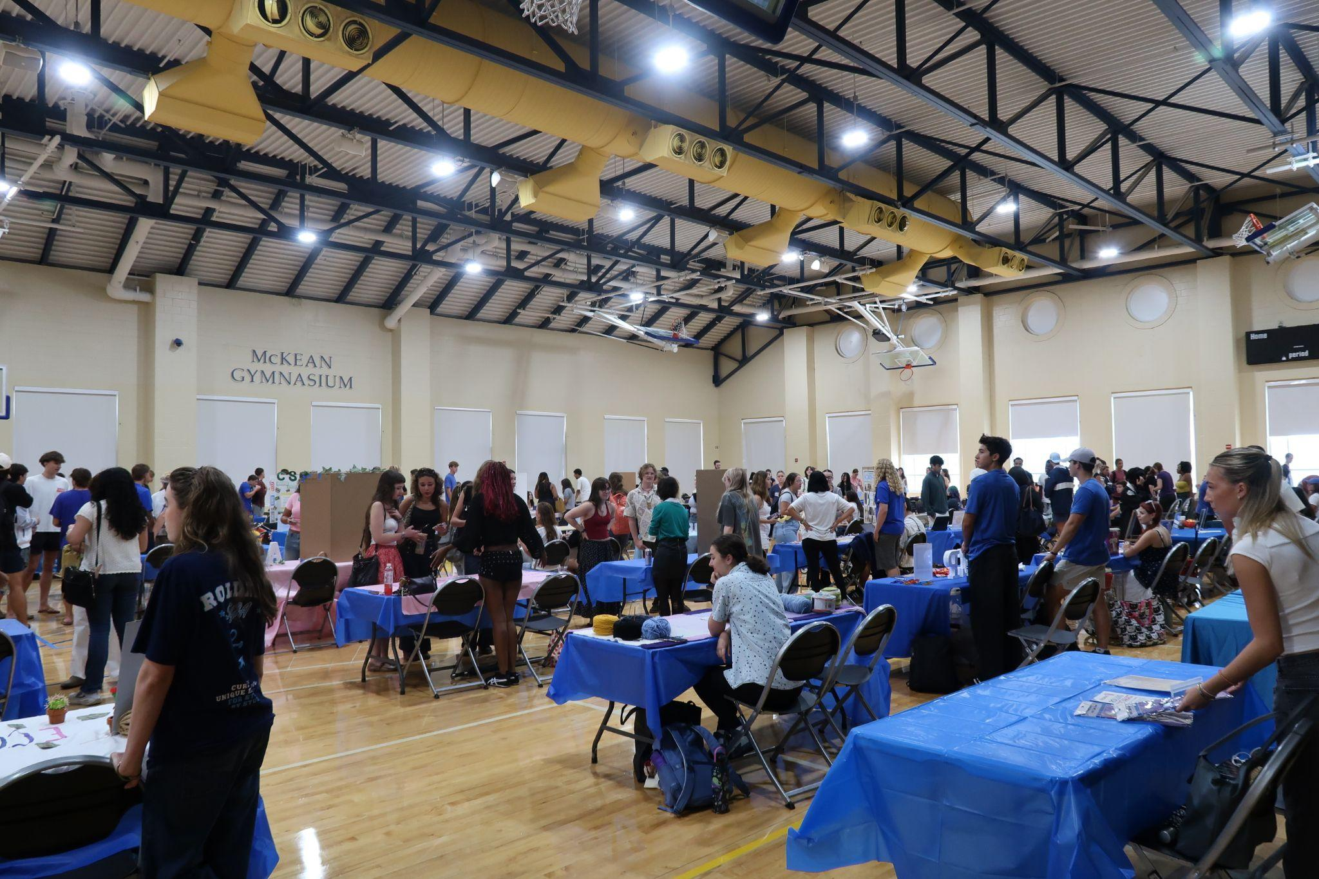

Booths lined up the auditorium, showing a diversity of interests and career paths among organizations, ranging from expressing cultural identity in Rollins Asian Studies Community to religious groups on campus such as YoungLife and leadership roles in Rollins’ Student Government Association (SGA).

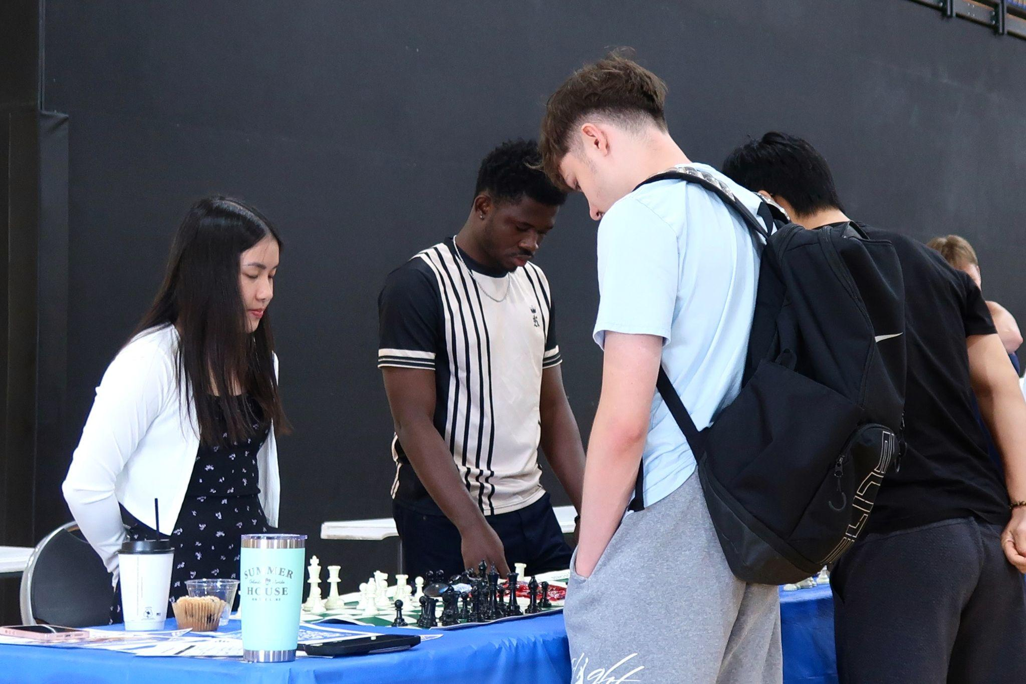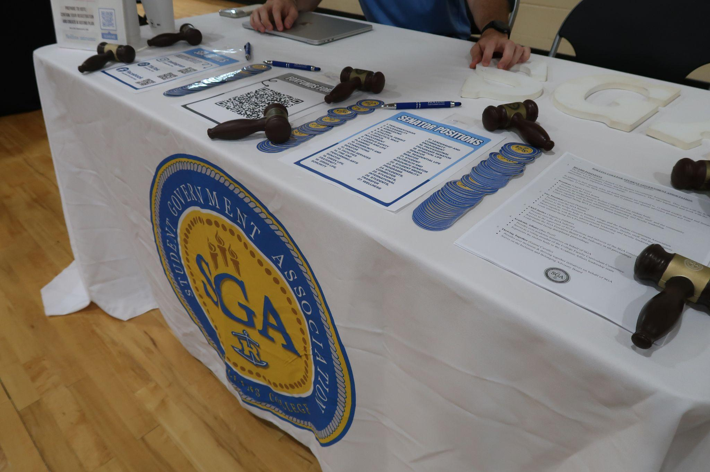
Club featured: Rollins Chess Society Club featured: Student Government Association (SGA)

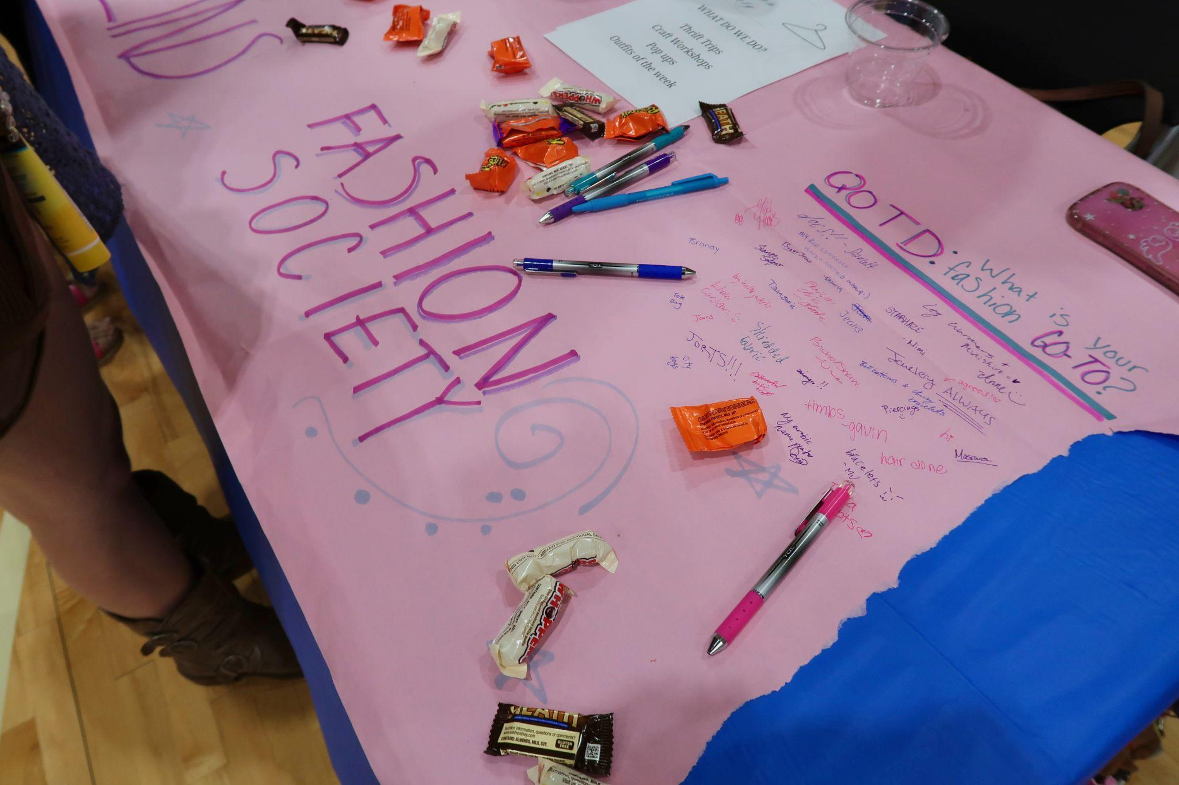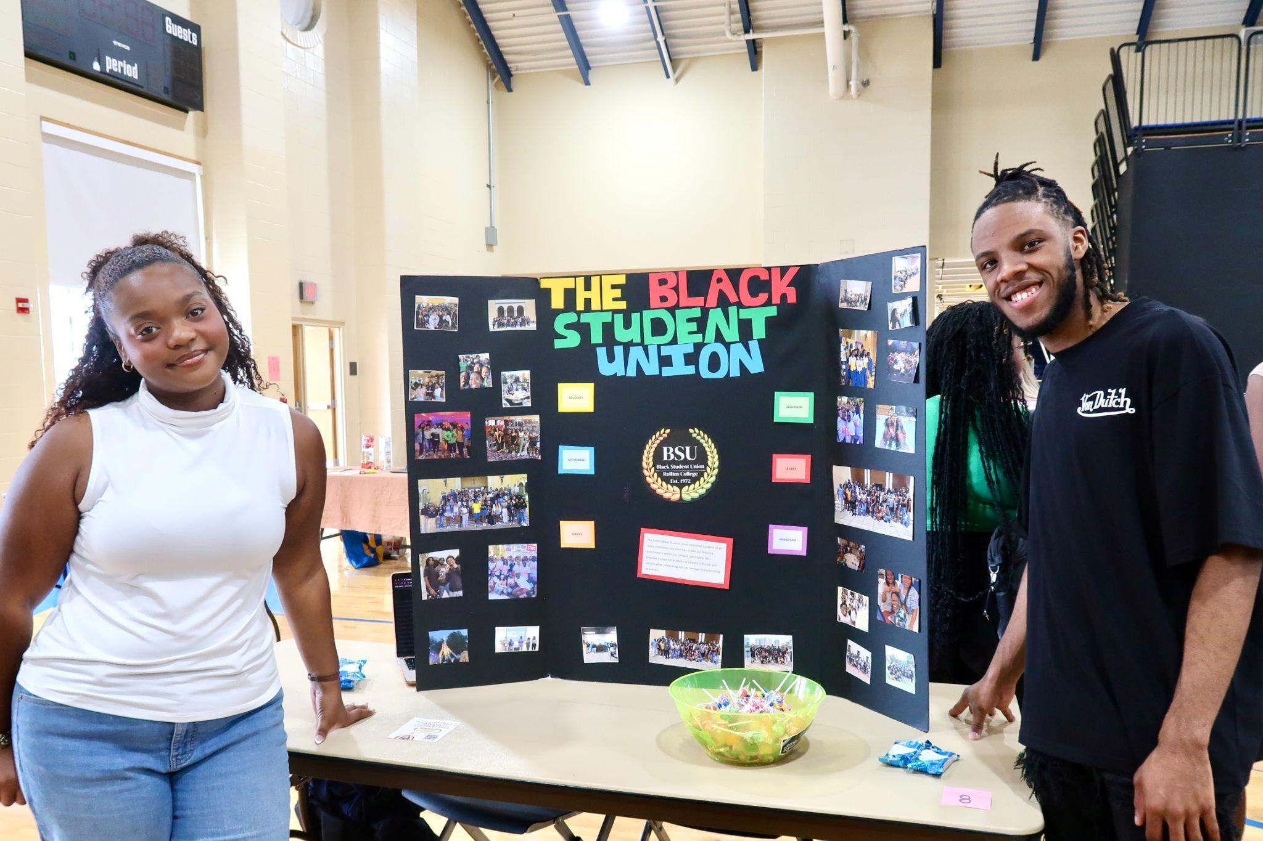
Club featured: Rollins Fashion Society Club featured: The Black Student Union (BSU)

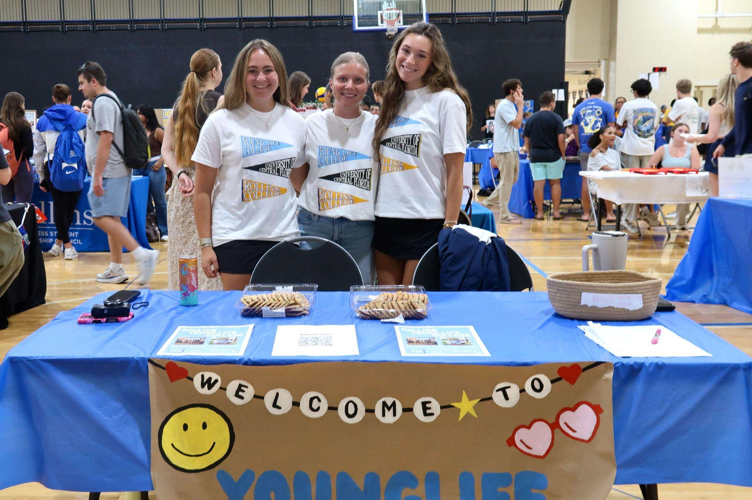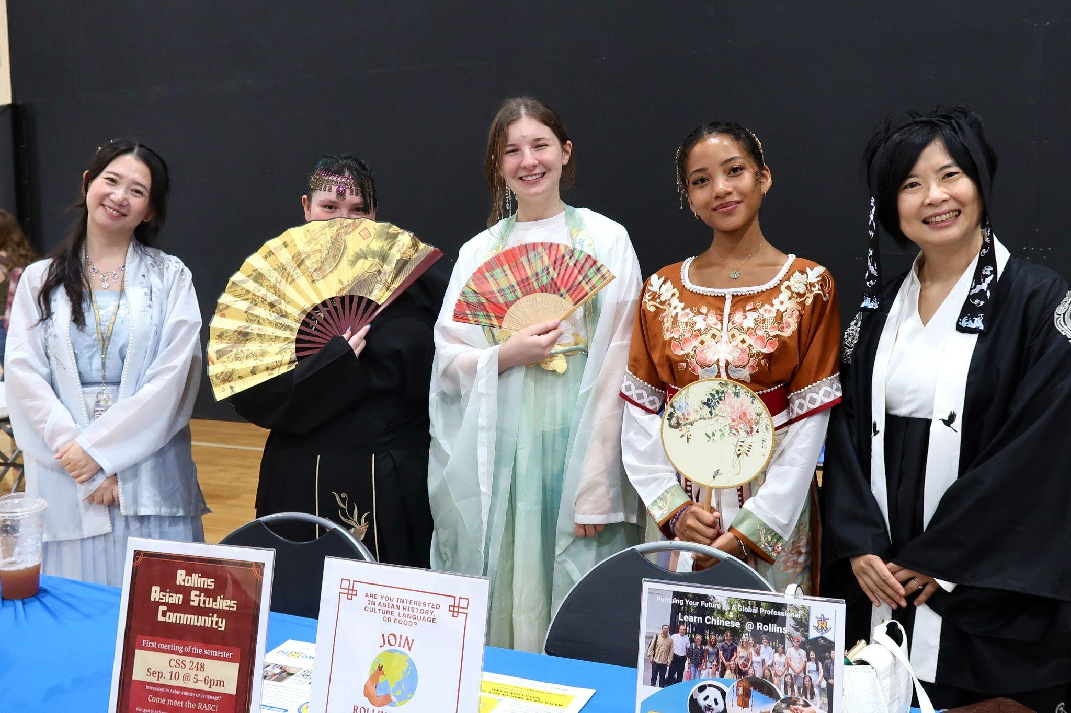
Club featured: Rollins Younglife Club featured: Rollins Asian Studies Community

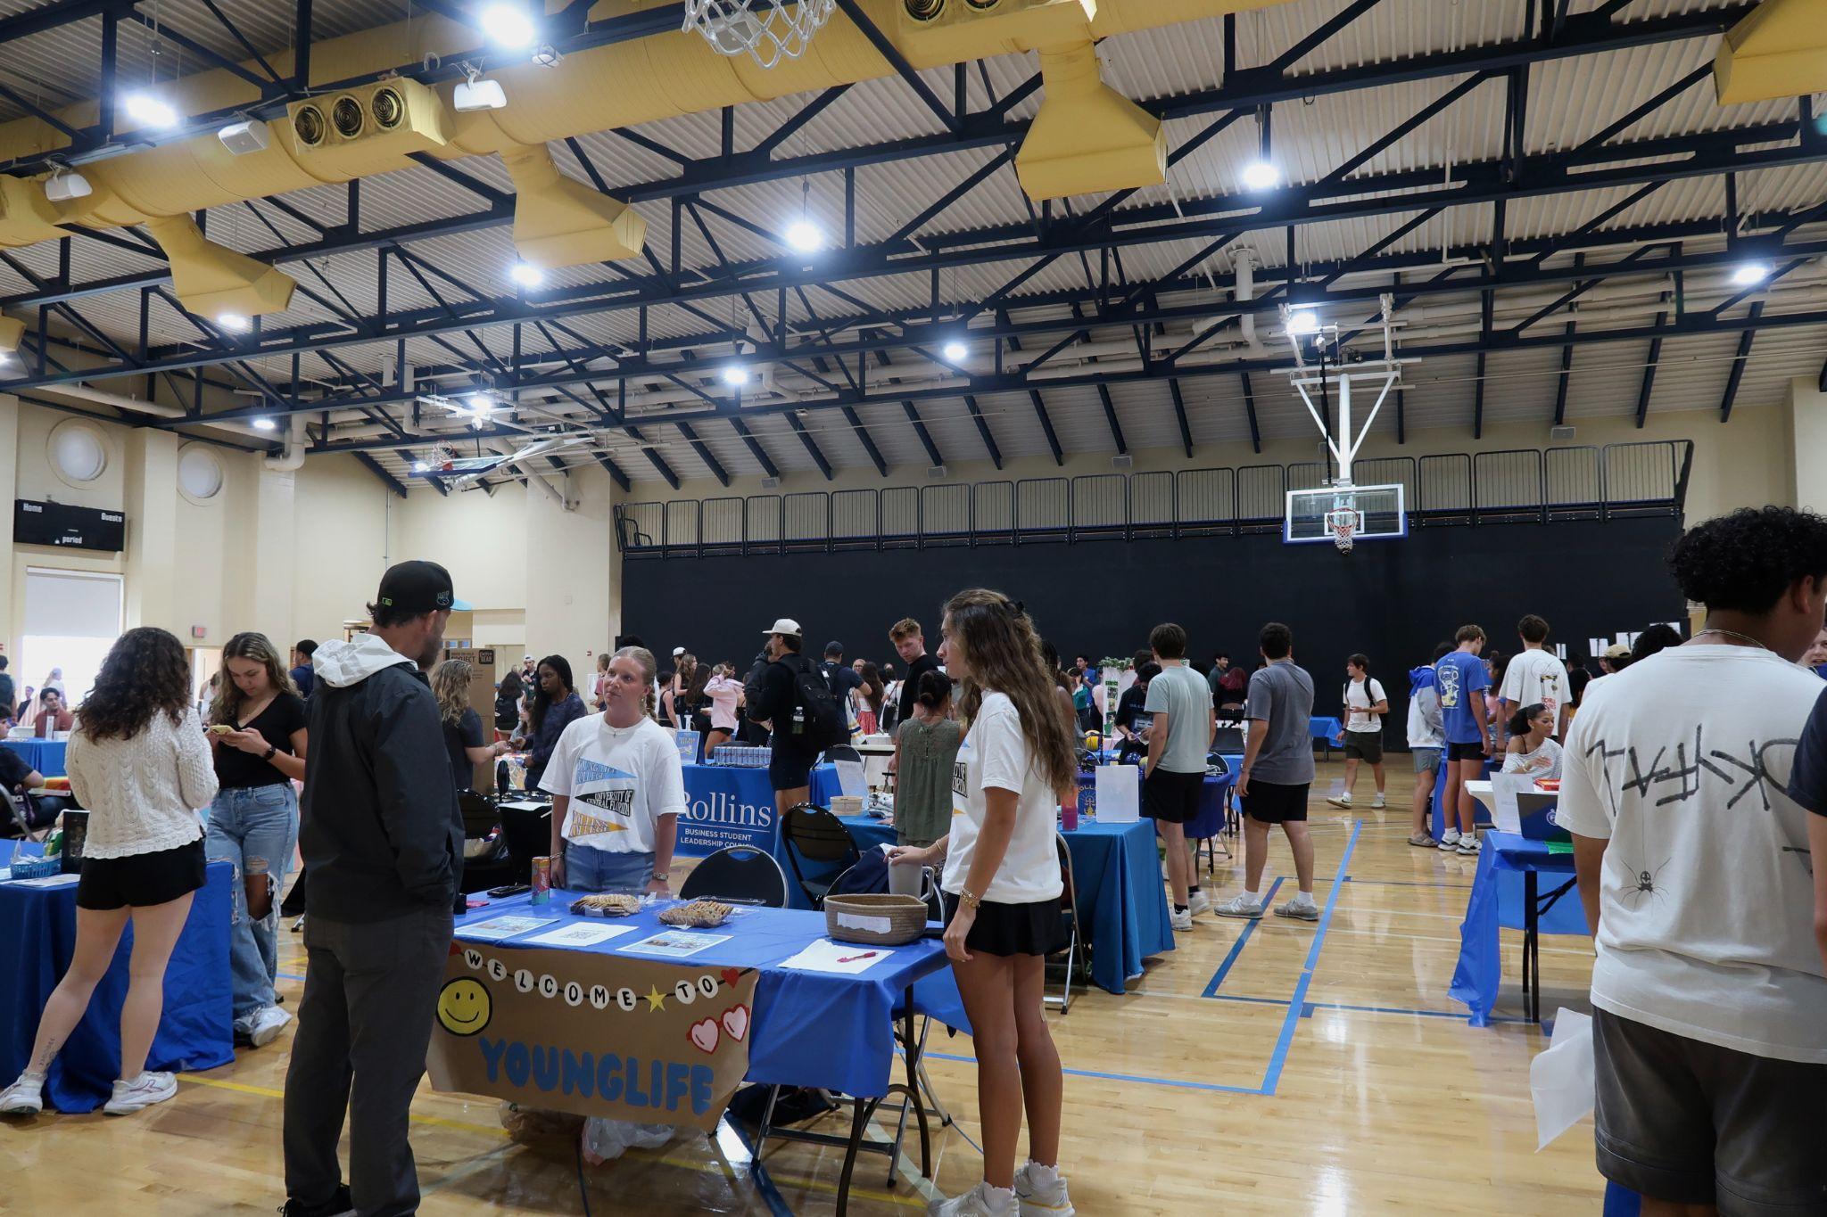

Our campus has a vibrant Greek life consisting of both national and local sororities and fraternities.

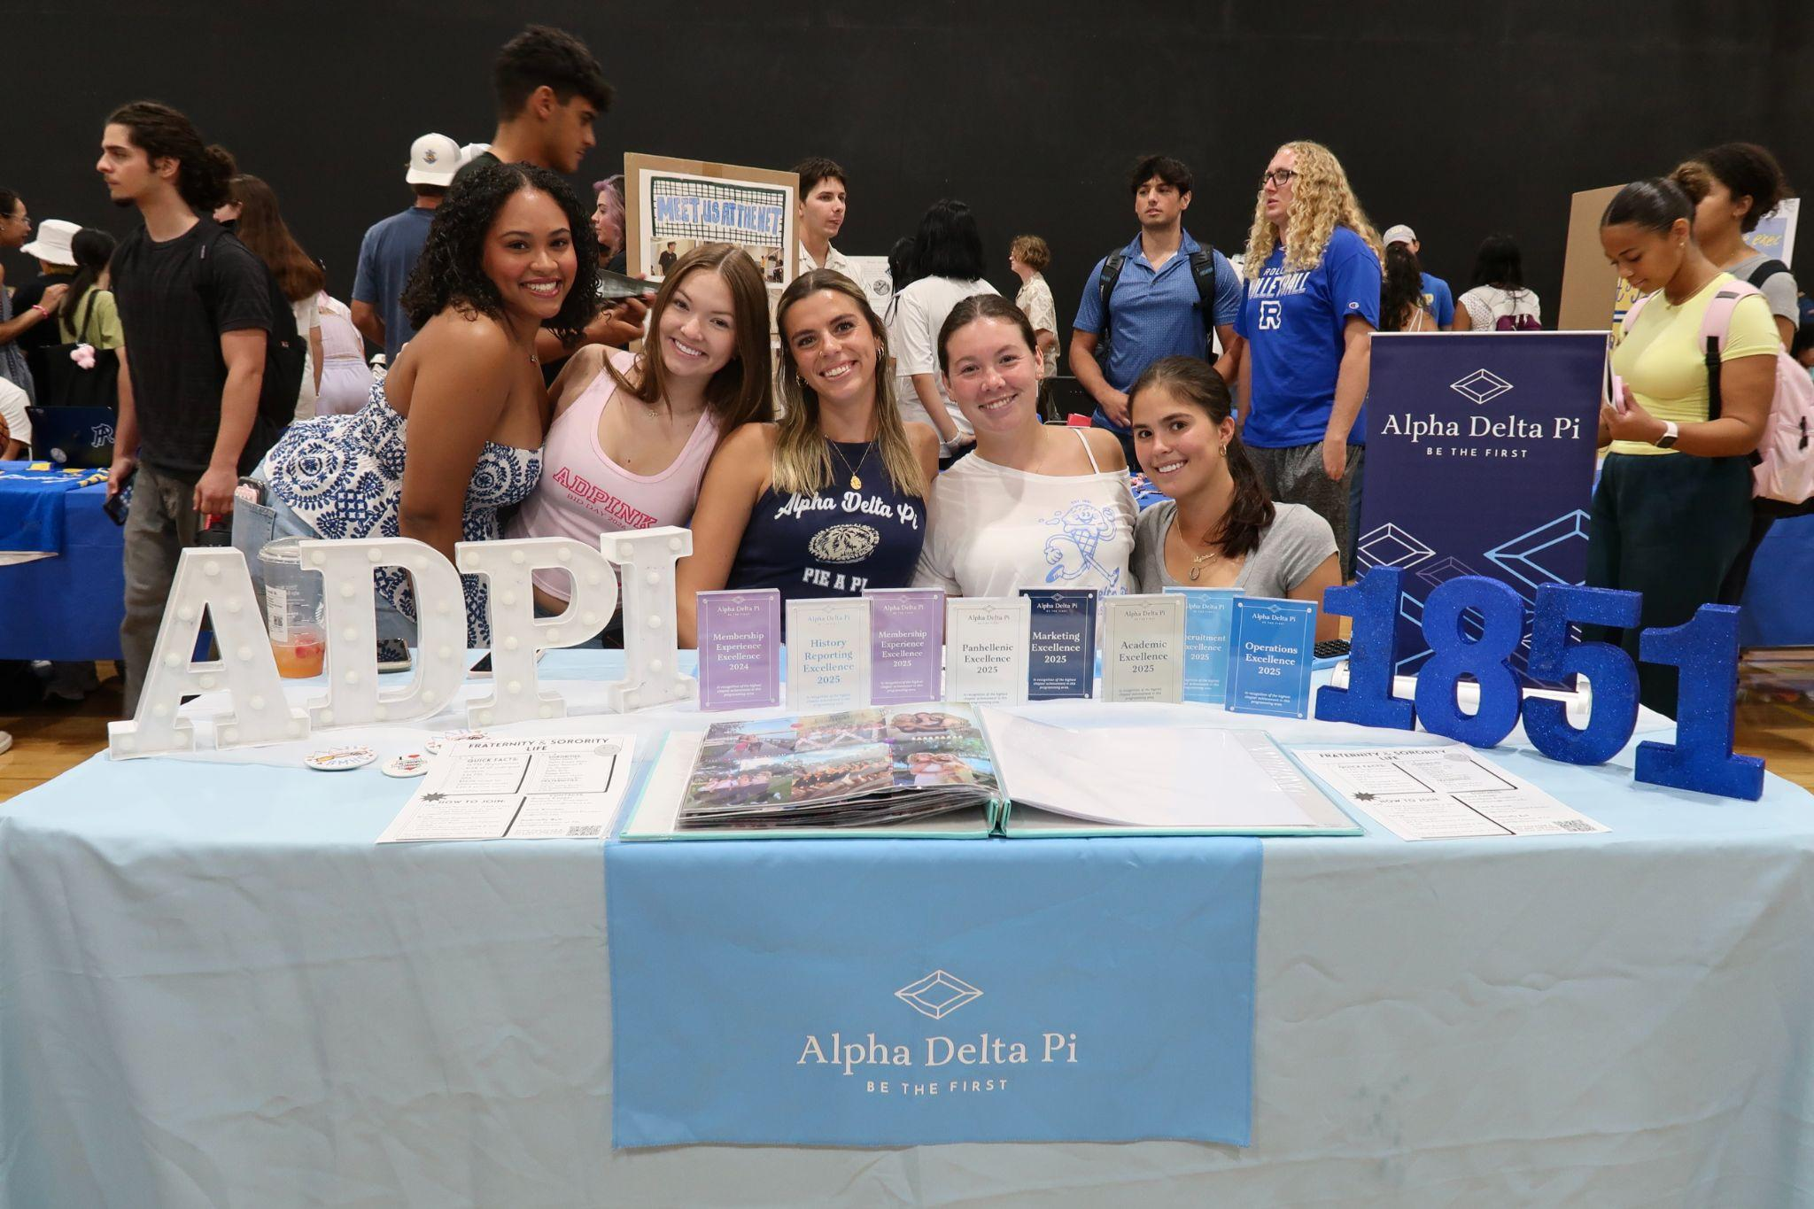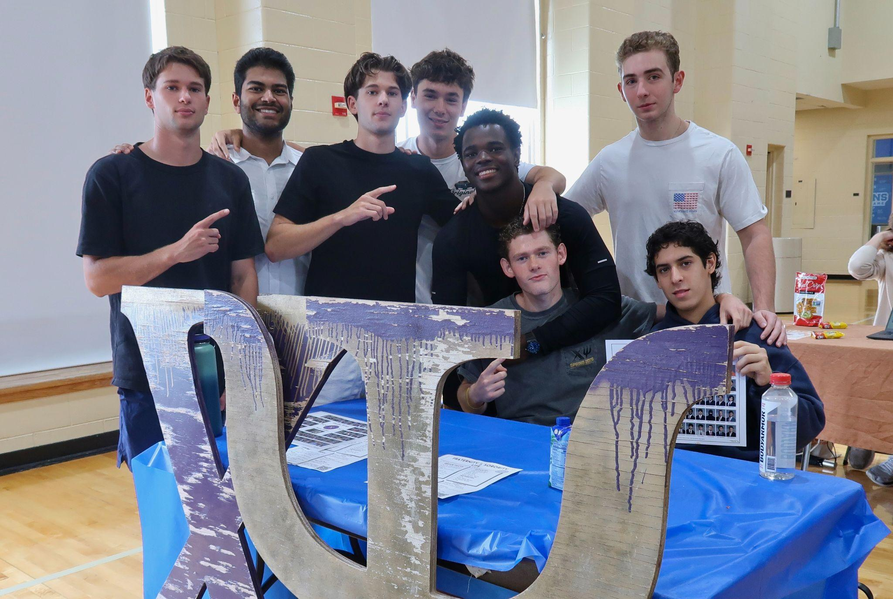
Sorority featured: Alpha Delta Pi (ADPI) Fraternity pictured: Chi Psi

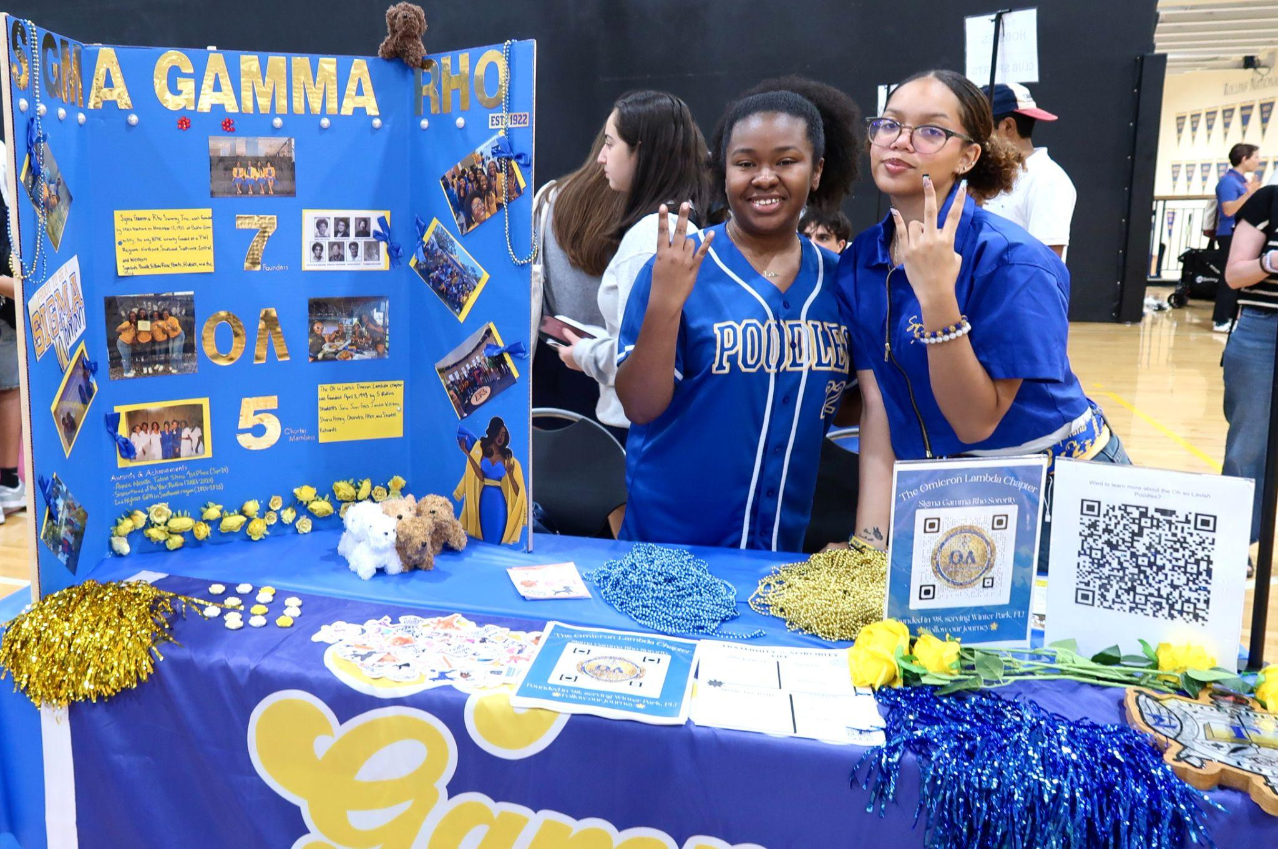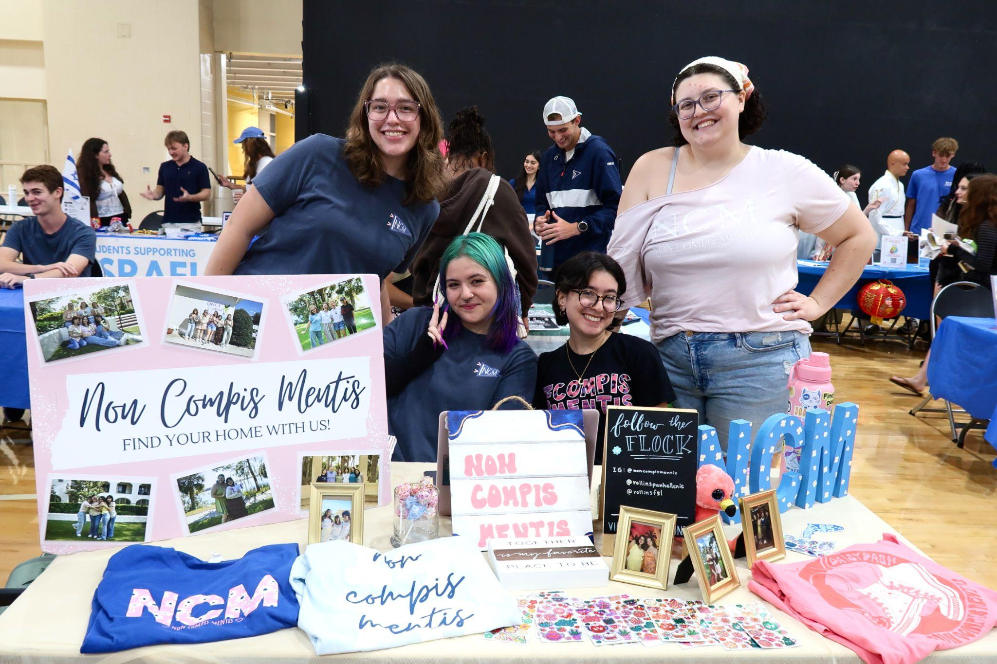
Sorority featured: Sigma Gamma Rho Sorority featured: Non Compis Mentis (NCM)

Rollins consists of multiple athletic clubs and sports teams on campus.

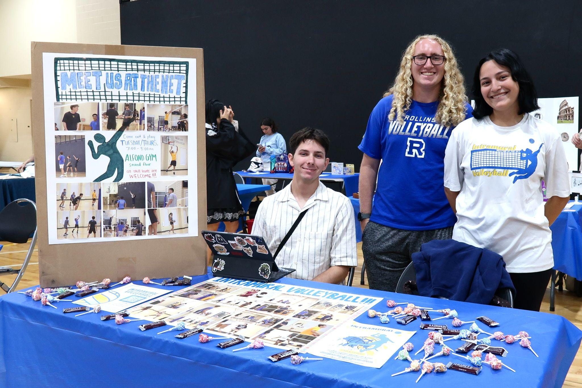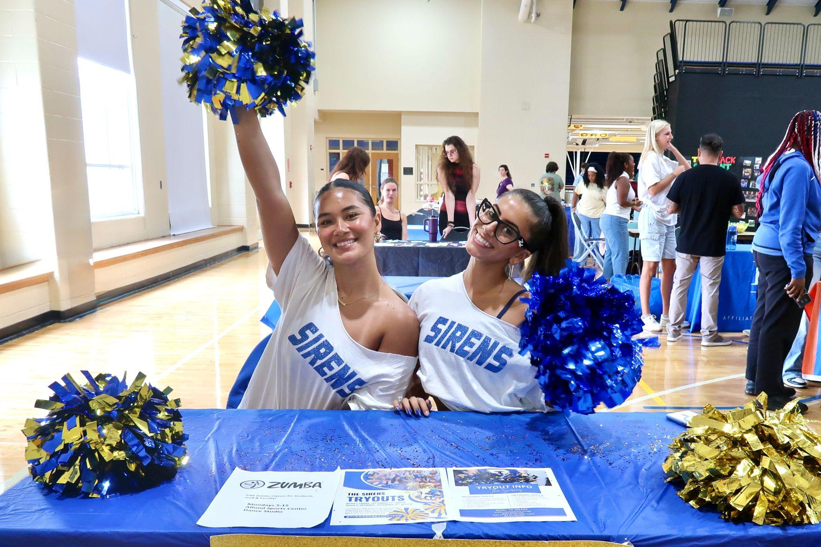
Club featured: Rollins College Intramural Volleyball Team featured: Sirens Dance Team

